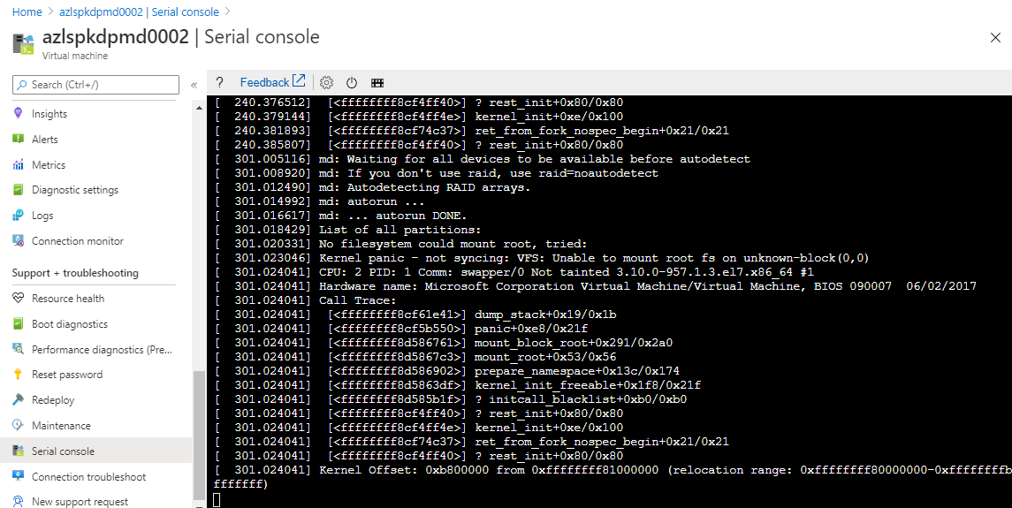

Select the Disk blade under Settings on the Problematic VM to get the OS Disk details

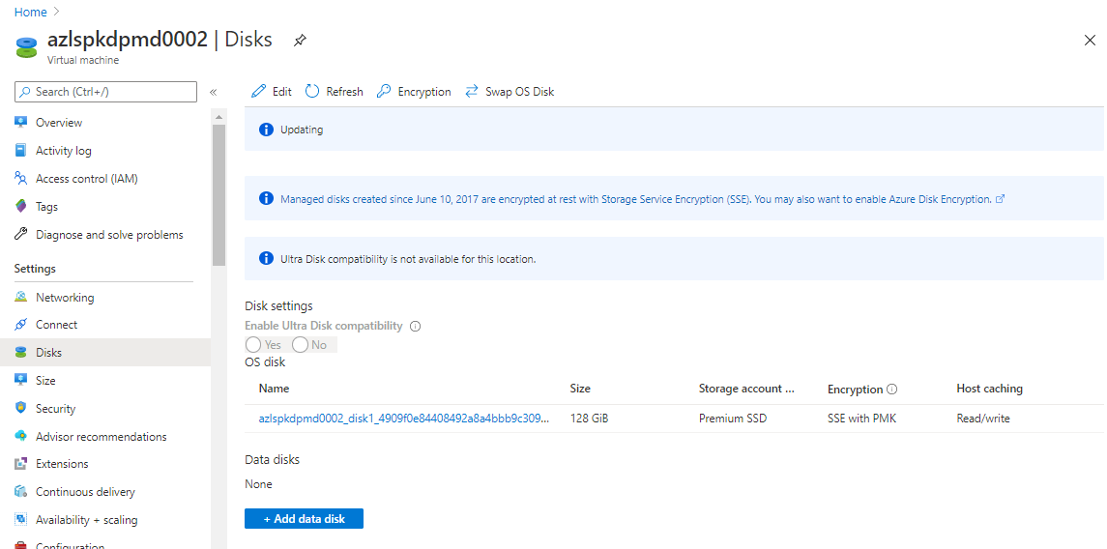

Select the OS Disk and Click on Create Snapshot to create one .

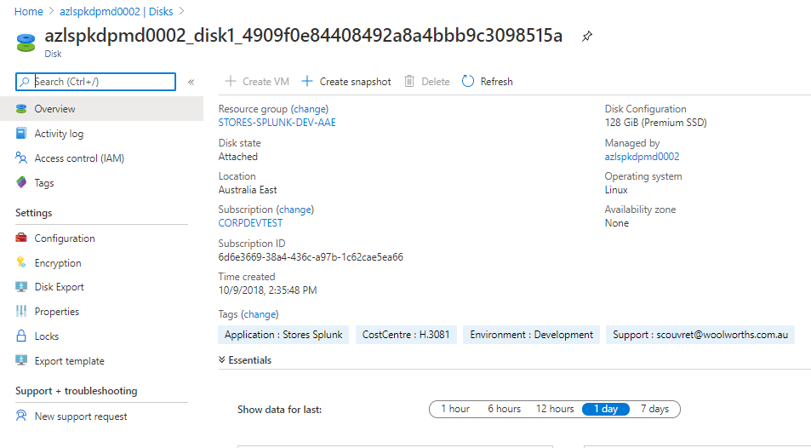

Enter the details for creating a new Snapshot for the OS Disk of the Problematic VM .

Resource Group Name: Create the Snapshot in the same Resource Group

Name: Name the Snapshot Name

Storage Type :- Select the storage type same as the OS Disk

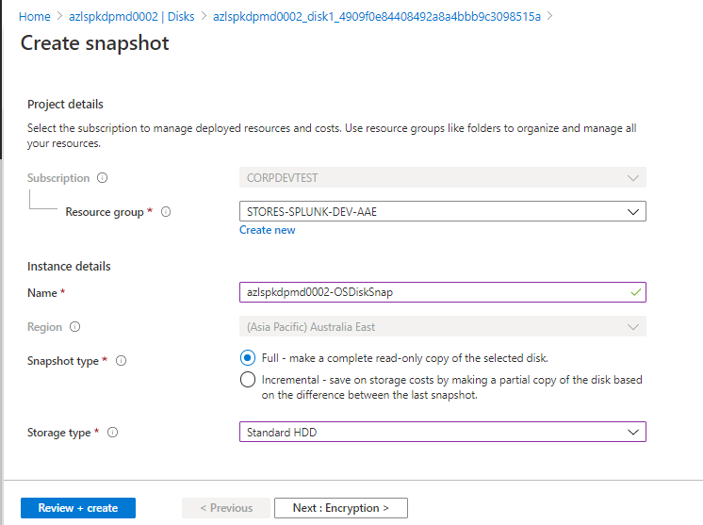

Click on Review and Create to create the Snapshot .

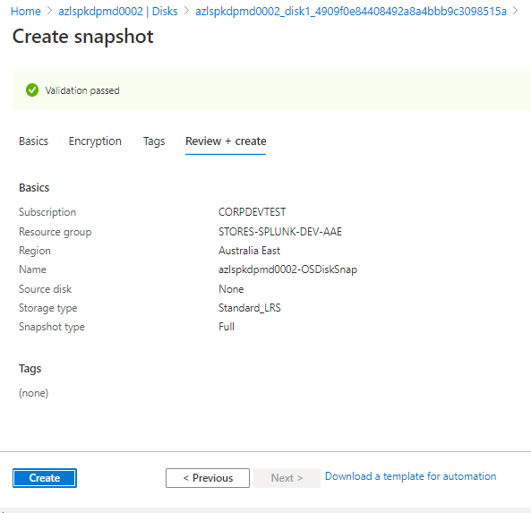

Once the OS Snapshot is created, select the Rescue VM from the Same Resource Group.

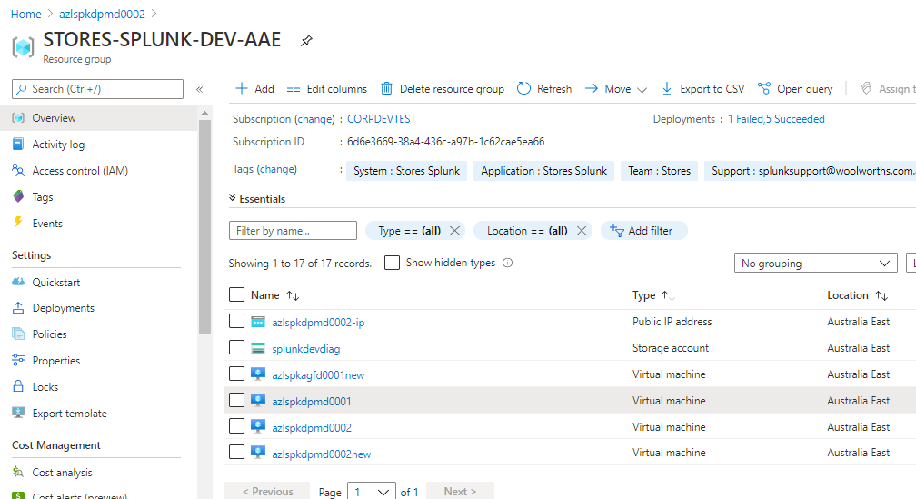

Select the Disk blade on the Rescue VM and Click on the Add Data Disk

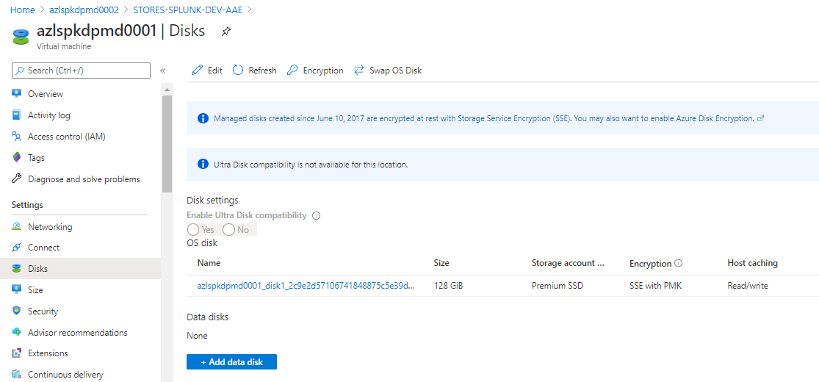

Click on Create Disk , to convert the Snapshot of the problematic VM OS Disk to data disk and attach it to the Rescue VM .

Click on Create the Data disk .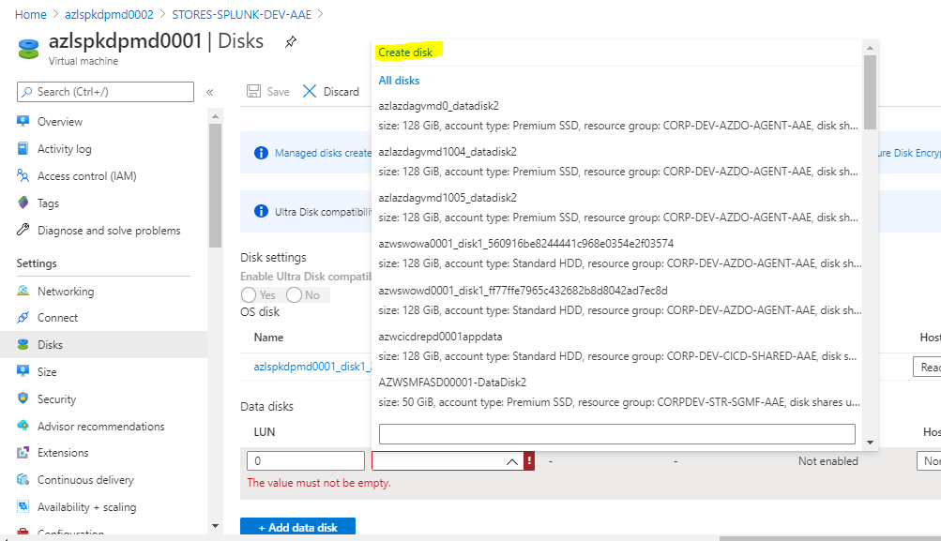

Enter the Disk name and select the same resource group , Make sure the source type to use the snapshot that we have taken on the problematic VM . The Disk size should be same as the OS Disk size..

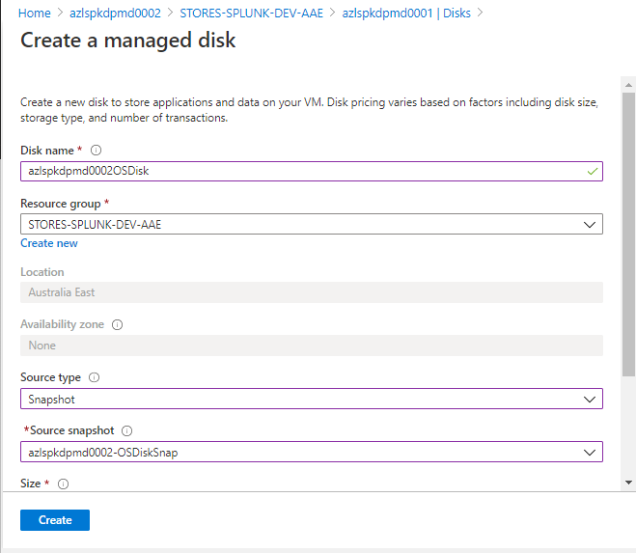

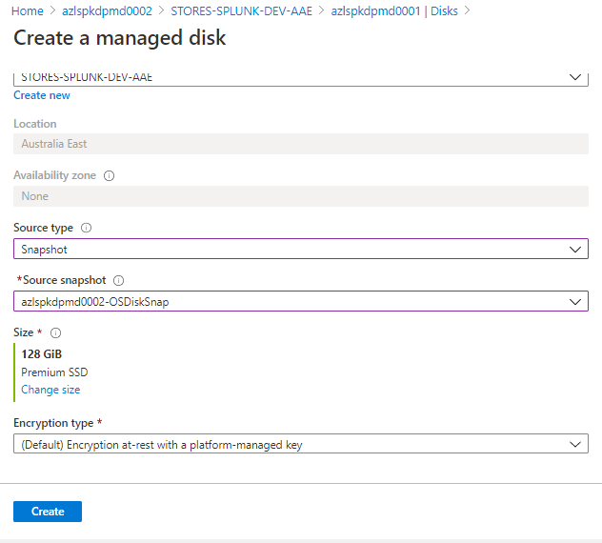

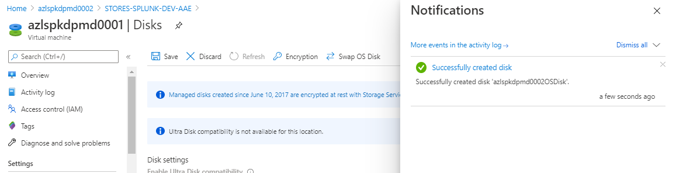

Select the Disk that we have created by using the Disk Snapshot and click on save .

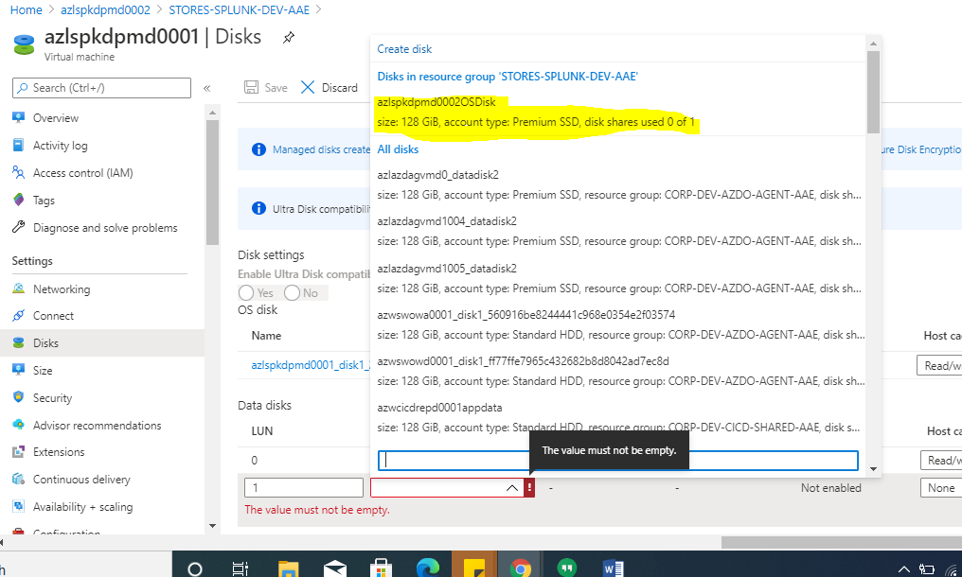

**SYSUnix task:-**

===========

1. Login to the rescue VM

2. Verify the faulty server disk is added using “lsblk” else scan.

3. Mount the faulty server partitions.

Eg-

mkdir /rescue ; mount /dev/mapper/vg00-lv_root /rescue… etc

Note : command differ for LVM/non LVM partitions

4. Change root to the faulty server FS.

chroot /rescue

5. Remove the newly installed kernel and install it again

yum remove <kernel-xx>

yum install <kernel-xx>

Verify the kernel is installed and have entry in grub file

Make sure initrd disk created for new kernel in boot partitions

6. Exit

7. unmount everything we mounted in order

8. Inform Cloud OPS team to detach the disk and swap to problematic server.

=======================================================================

Once the trouble shooting is completed from the Sysunix team we have to Dettch the Data disk that we added on the Rescue VM .

Click on the Disk blade of the Rescue VM and click on Edit and then select the Disk that we created to Dettach from the Rescue VM.

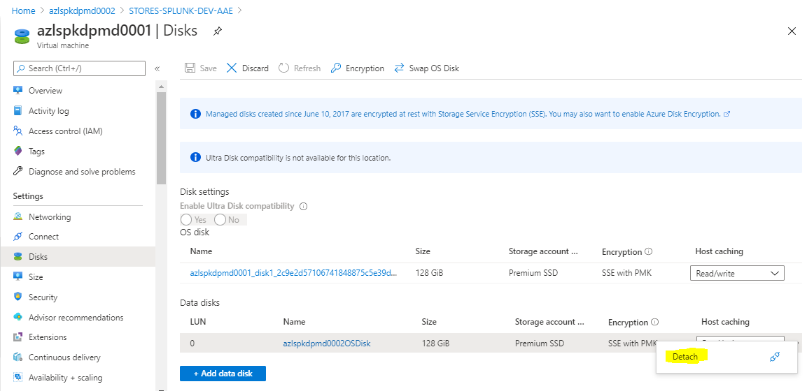

Once we complete the Task , we have the Mount the Disk as the OS disk on the problematic VM .

Select the Disk blade and click on Swap OS Disk to add the new OS Disk .

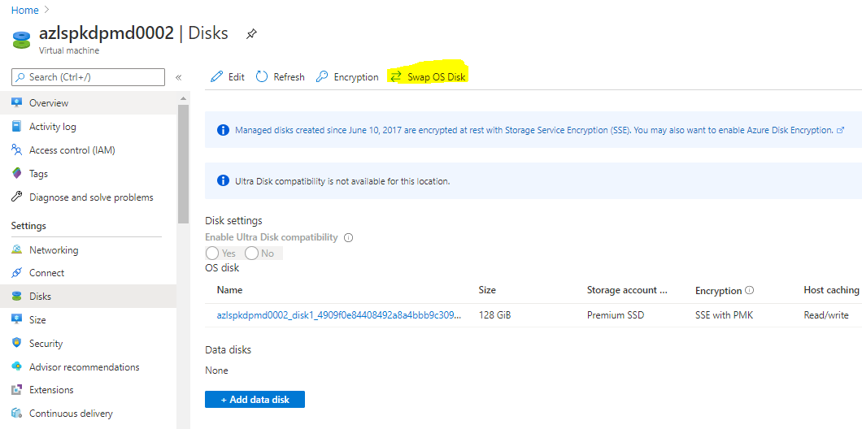

Select the Disk the we created by using the Disk Snapshot and confirm the sever name where we swapping the Disk and click on OK to save the settings .

